Dataset

<https://raw.githubusercontent.com/urwithajit9/ClaMP/master/dataset/ClaMP_Integrated-5184.arff>

Hoeffding Tree

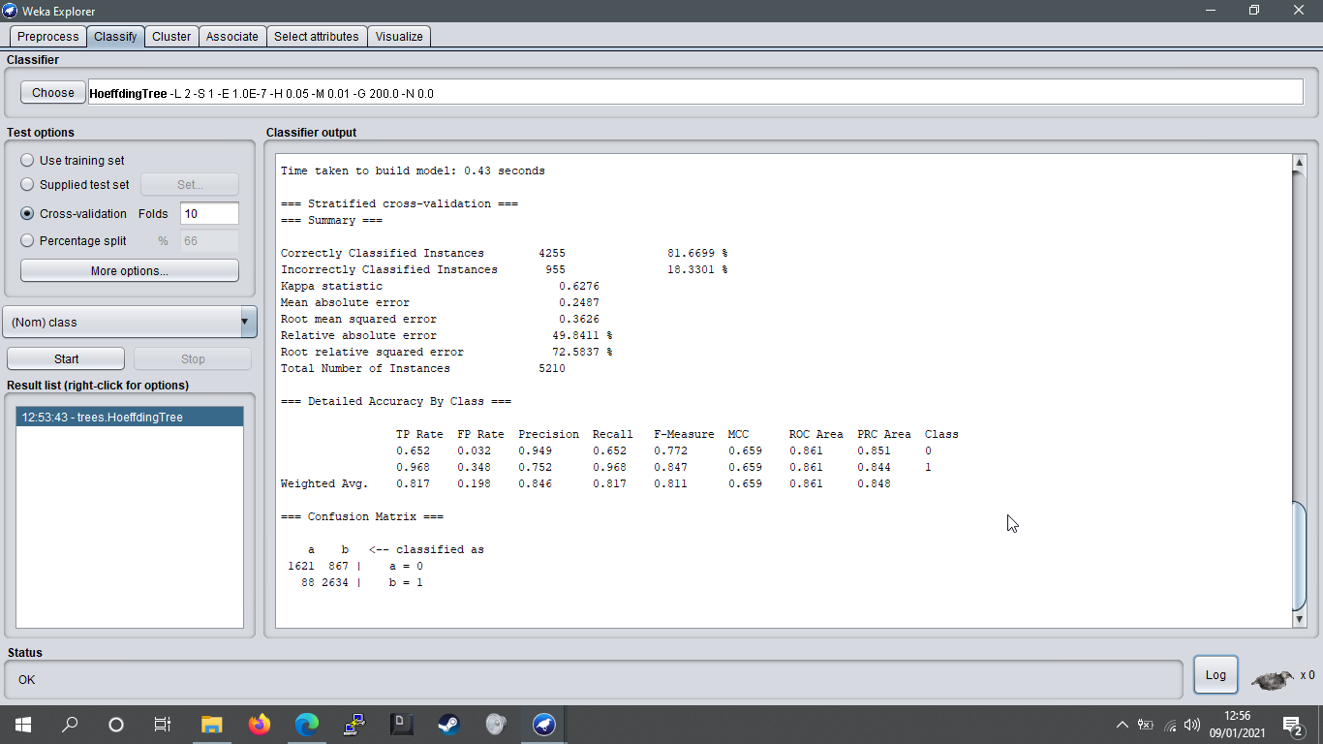

Decision Stump